Autumn 2023 Year 5/6 Recommended Reads

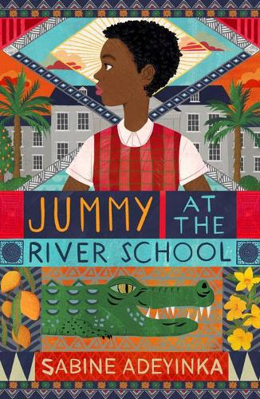
Jummy at the River School by Sabine Adeyinka
Jummy is excited about joining at an elite boarding school in Southern Nigeria, but her joy is clouded by disappointment when her best friend Caro is not accepted. Caro arrives unexpectedly, not as a student, but as a servant, just as Jummy is settling in and making new friends…

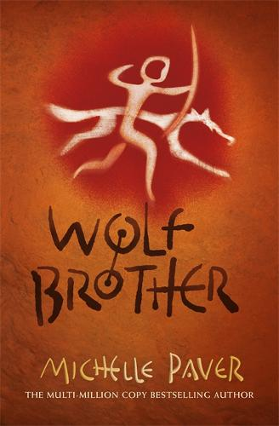
Wolf Brother by Michelle Paver
In a dark world set many millennia, 12 year old Torak must take a dangerous journey to the mountain of Wolf Spirit and save the world from a dangerous demon…

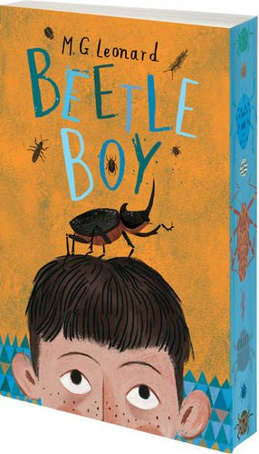
Beetle Boy by MG Leonard
When Darkus’ Dad vanishes, he finds himself living next door to the neighbours from hell. When things can’t seemingly get any worse, a super-intelligent talking beetle comes to the rescue…

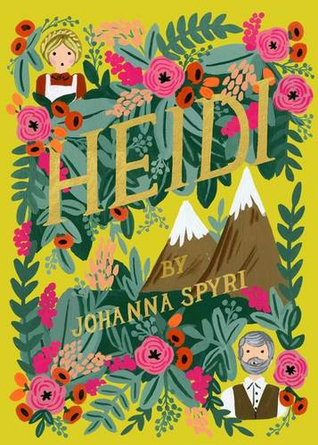
Heidi by Johanna Spyri
Heidi is an orphan left broken hearted when she has to leave her grandfather and home in the mountains to live in the city. This classic book will appeal to children who love the great outdoors.

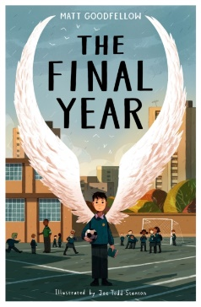
The Final Year by Matt Goodfellow
The end of Year 5 through to the end of primary school is told though fragments of life in this powerful verse story. Year 6 children will empathise with Nate and the challenges he faces at home, his struggles with bullying at school, and deciphering what really matters between the ages of 10 and 11.

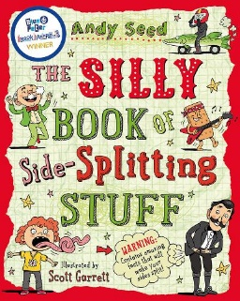
The Silly Book of Side-Splitting Stuff by Andy Seed
An extremely funny book of facts and true stories which will appeal to all readers. A great book for Year 6 children to dip into.

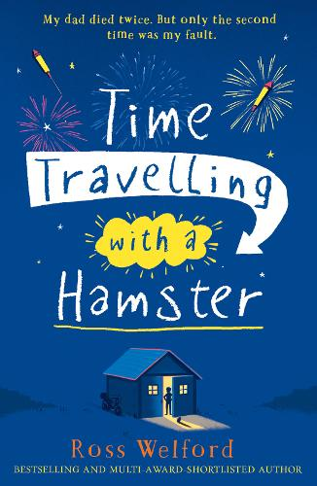
Time Travelling with a Hamster by Ross Welford
A moving story about time travel. When Al reads a letter it sets off a chain of events in which he races to travel back to 1984 to try and save his late father…

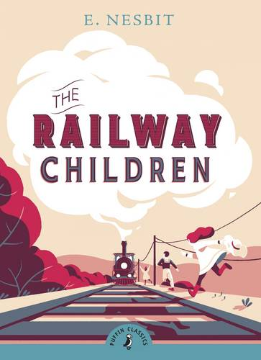
The Railway Children by E. Nesbit
A classic story of adventure and loss. Three children and their mother leaves their lives in in London to live in a small cottage in the country. Will they discover the mystery of their father’s disappearance?

