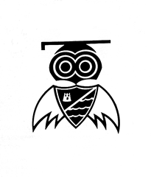
Greenleas Primary School
Green Lane
Wallasey
Wirral
CH45 8LZ
Tel No: 0151 639 1225 / Fax No: 0151 639 4349
Headteacher: Mrs Sharon Edwards
Be nice, work hard, never give up

E-mail: schooloffice@greenleas.wirral.sch.uk
Website: www.greenleasprimaryschool.co.uk
Twitter: @greenleasps

15th January 2021

Dear Parents and Carers,

Another week has passed and information from the Government is still coming in thick and fast. However, I hope that you as a family are beginning to settle down into some routine. We are all impacted by the current situation and sadly some of our families are suffering at this extremely difficult time - our thoughts and prayers go out to you. Please remember that we are here for you, all you need to do is contact us at schooloffice@greenleas.wirral.sch.uk , we will be more than happy to help you in any way we can.

I have been blown away by the dedication of Greenleas staff this week. Despite us not having any internet in school, staff have remained highly committed to providing children with the best education possible given the circumstances. Not only are they all teaching full time in school providing lessons to children from critical worker families and those that are deemed vulnerable, they are also supporting those children who are learning at home (and managing family life too!).

At the end of the first full week of remote working, we are extremely grateful for all the positive messages of support that we have received. Your feedback is valued. I appreciate that this is a situation that none of us want to be in and understand that there are many working parents who are juggling jobs from home whilst trying to be there to support home learning. We understand that you are not teachers and are extremely grateful for all that you are doing. Thank you.

When planning our remote learning provision, we ensured that we took into account the guidance recommended by OFSTED. They understand there is a tendency to think that a live lesson is the ‘gold’ standard of remote learning, but acknowledge this isn’t necessarily the case. For young children, it can be hard to build in interaction and flexibility and evidence suggests that concentration online is shorter than the length of a typical lesson. It is harder to engage and motivate pupils remotely, therefore we are trying to ensure we offer a variety of learning opportunities chunked into smaller activities. These include videos, presentations with pre-recorded instructions, Google Class Meets, pre-recorded stories etc.… We will continue to reflect on our provision, our staffing capacity and adapt to meet the needs of the children in any way we can. Please continue to bear with us as we grapple with this new way of working too.

The number of children currently accessing our critical worker provision remains high. Each week we will continue to review the number of places we can offer, if demand is higher than our staffing capacity we will have to further prioritise our places to the children of NHS, Emergency Services, Social Care and Education workers only. Where there is an adult at home we expect children to remain at home too. The government message is clear, stay at home if you can. The safest place for adults and children alike is in the home. I greatly appreciate those of you who are keeping your children at home where you can. I think that this is the only way we will be able to move back towards normality in the coming weeks and months.

We really look forward to the time when we can all be together again. In the meantime, please remember to stay safe and focus on you and your families’ well-being and maintaining a strong and resilient mind set. So that everyone remains on top form don’t forget to engage in those ‘little escapes’ while being at home- games, books, films, baking, crafts etc.… Below are some links that can support positive well-being during these challenging times:

- https://www.elsa-support.co.uk/category/free-resources/ Some good free resources for social and emotional support for children, including positivity games, stories linked to coronavirus, well-being calendars etc.…
- https://www.youtube.com/user/CosmicKidsYoga For looking after your body and mind.
- To support mental health needs in both children and adults
  - Wirral CAMHS (Child and Adolescent Mental Health Services) is a specialist mental health service that works with children and young people with moderate to severe mental health problems. CAMHS offers support to children and young people who are experiencing difficulties with the way they are thinking or feeling which are impacting on their mental health Information about their services for children and young people can be found at https://www.mymind.org.uk/
  - Wirral CAMHS also have a 24 hour mental health support phone number: 0300 303 3972
  - Young Minds is a really useful site and has many real life events from young people to help and support young people. https://youngminds.org.uk/
- Weekly HeartSmart video lessons will be uploaded onto the Google Classroom for children to participate in.

Unfortunately, the problem with our internet/server continues into next week. Apparently, our server being offline may have affected some of you receiving communication via ParentMail. All communication sent out by ParentMail will also be uploaded to the website (COVID Updates Jan 21). For your information key communication sent out w/c 11.01.21 included:
- Letter from Paul Boyce Director for Children, Families and Education (email)
- Free School Meal Vouchers (email and form)
- Critical Worker Provision w/c 18.01.21 (form)
We will keep you updated on progress with the server/internet. Hopefully, it won’t be too much longer!

Please look after each other. Be kind, be careful and stay safe,
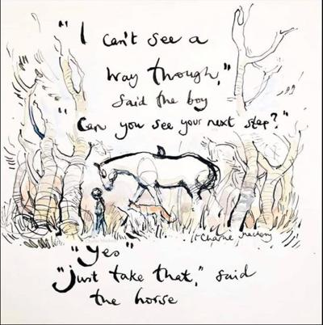

Sent with my very best wishes

Mrs Sharon Edwards
Headteacher

